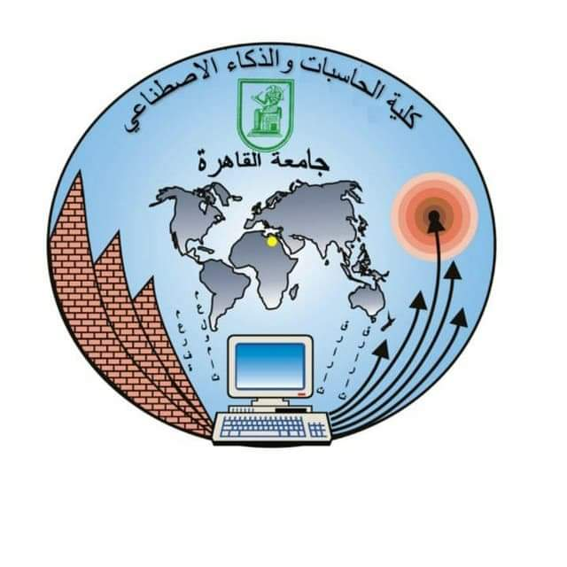

Subject : web project

Project name : Student Affairs website

Project number: Project 2

Group number: s13-14

|  |  |
| --- | --- |
| Name | ID |
| Nora Mohamed Hussein | 20201196 |
| Heba Abdelwahab Sayed | 20201208 |
| Osama Karam Karam | 20200071 |
| Ezz El Deen Fahmy Radana | 20201116 |
| Zeinab Ali Ahmed | 20201083 |